HORN & LAURETTI
225 FRIEND STREET, SUITE 204

BOSTON, MA 02114
(617) 589-3000

FAX (617) 523-3812
JOHN M. HORN DENISE M. LAURETTI*
MICHAEL S. KINSON* JEFFREY D. SWARTZ

*Admitted in MA and NH

Fred Desmarais, Jr., Esquire
Desmarais, Ewing & Johnston
175 Canal Street
Manchester, NH 03101

RE: Gauvin vs. Kendallwood Condominium, Cityside Management, B&C
Rockingham County Superior Court Division Civil Action No.: 09-C-439

Dear Attorney Desmarais, Jr.:

Attached please find copies of documents sent to the plaintiff’s Attorney, Peter Solomon, pursuant to Rule 30 and Rule 45 of the Massachusetts Rules of Civil Procedure for the following locations and relating to the above-captioned matter:

See Attached Location List 'A'

Thank you for your attention to this matter.

Very truly yours,
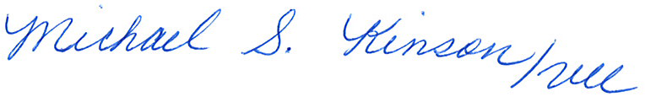

Denise M. Lauretti

MSK/vll
Enclosure
Cc: Elizabeth Hurley and Peter SolomonDenise M. Lauretti, Philip Pancoast and Rick Woods

Order No. 01-18863-001 thru 007

Staff Counsel: Hanover Insurance Company/Citizens Insurance Company
Not a Partnership

